SAVEETHA SCHOOL OF ENGINEERING
CSA15- CLOUD COMPUTING AND BIG DATA ANALYTICS
LIST OF EXPERIMENT 1
1. Create a simple cloud software application and provide it as a service using any Cloud Service Provider to demonstrate Software as a Service (SaaS).
SOL:
AIM:
To design and implement a simple cloud-based Hospital Management System application using Zoho Creator and deploy it as a Software as a Service (SaaS) application, demonstrating database relationships via lookup fields, role-based multi-user access, and real-time cloud data management without local installation.
PROCEDURE:
- Sign In: Sign in to the Zoho Creator cloud platform using the registered student account credentials.
- Application Shell: Create a completely fresh standalone application by selecting the Create from Scratch option and name it SaaS Experiment 1 Hospital Management.
- Form 1 (Doctors Table): Design the first data entry form named Doctors, adding a Name field labeled Doctor Name and a Single Line text field labeled Specialization. Publish and save the form.
- Form 2 (Patients Table): Design the second data entry form named Patients, adding a Name field labeled Patient Name and a Number field labeled Age. Save the form configuration.
- Form 3 (Appointments Relational Table): Create the third form named Appointments to establish the relational cloud architecture:
  - Drag a Lookup Field linking directly to the Patients form, choosing Patient Name as the display value.
  - Drag a second Lookup Field linking directly to the Doctors form, choosing Doctor Name as the display value.
  - Add a Date field labeled Appointment Date to capture schedule info.
- Report Generation: Automatically generate separate, dedicated list view reports for Doctors, Patients, and Appointments to enable data sorting and search indexing across the cloud environment.
- Deployment & Multi-Tenancy Execution: Click on the blue Access This Application button to publish and deploy the application live onto the Zoho cloud infrastructure.
- Functional Cloud Testing: Populate the live multi-tenant cloud application database by sequentially inserting 3 unique sample entries into the Doctors form, 3 entries into the Patients form, and subsequently executing cross-table relational links inside the Appointments form.
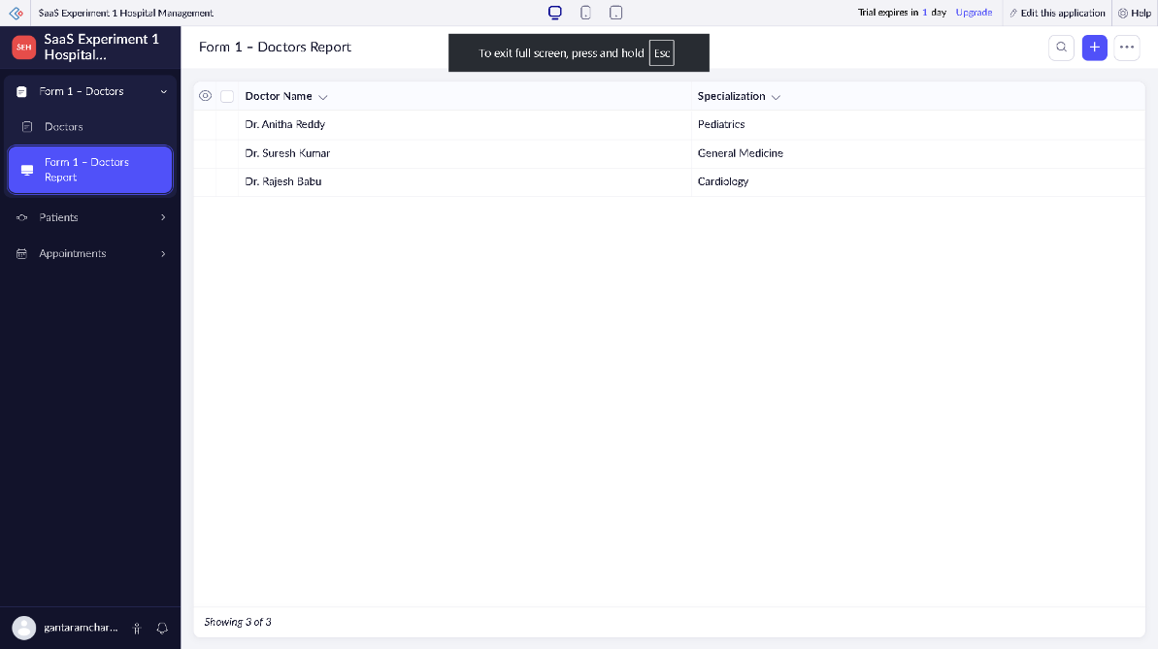
SNAPSHOTS:

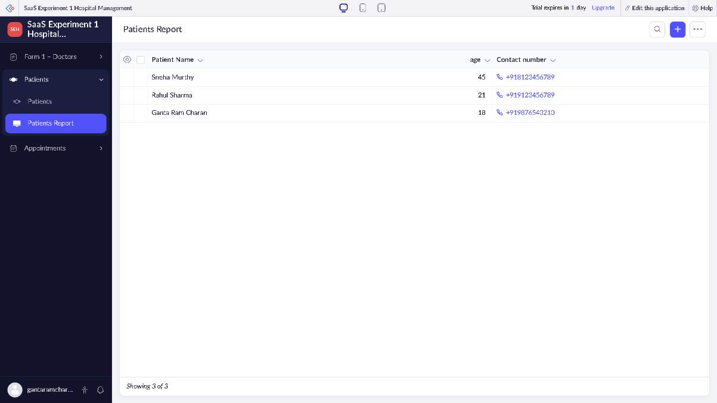

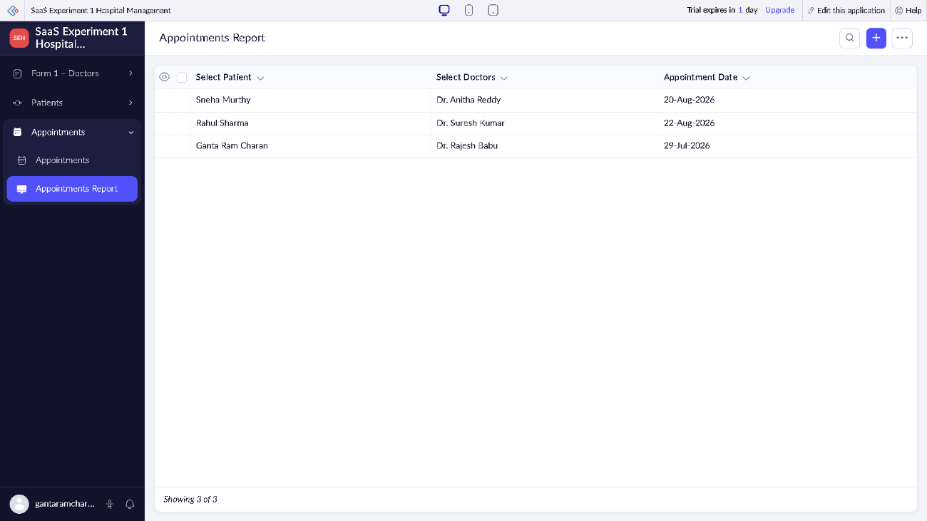
RESULT:
A relational cloud-based Hospital Management System application was successfully developed, integrated, and deployed utilizing the Zoho Creator service provider infrastructure. By enabling multiple database tables to relate dynamically via lookups and rendering the entire layout seamlessly inside a web browser window without local hardware installation, the deployment perfectly demonstrated core Software as a Service (SaaS) operational models.

